Assignment Description
- Write and test two programs
  - Use selection sort for linked lists.
  - Use merge sort for linked lists.
- Compare the efficiency between the merge and selection sort.
- Test with AT LEAST lists with these number of elements
  - 1
  - 10
  - 100
  - 1000
- You will need to know the time in milliseconds to run each and graph the comparison of n vs time.

1 Readme Documentation
This program creates a linked list of variable length and then measures the amount of time to sort it using selection sort and merge sort. The user is able to change the number of elements in the randomly generated list and the time to sort is measured in microseconds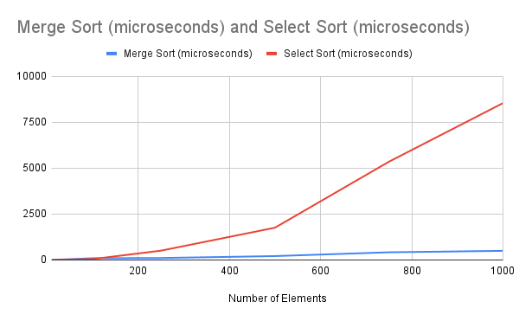
The merge sort follows the expected O(nlog(n)) efficiency and the select sort follows an O(n^2) curve. I stopped the number of elements at 1000 because the merge sort becomes hard to see when the select sort blows up in completion time.
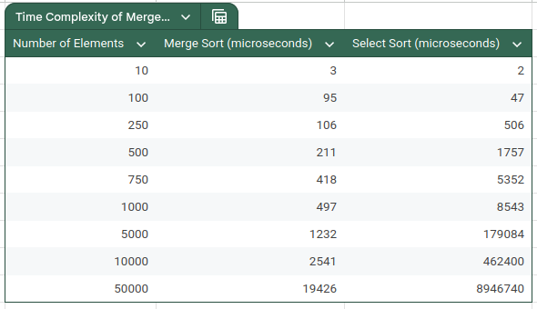

2 Flowchart Screen Shots

3 UML and Use Case Diagrams

4 Source Code of All files (.h, .cpp)
#include <iostream>
#include <limits>
#include <algorithm>
#include <chrono>

template <class Type>
class nodeType{
public:
Type info;
nodeType<Type>* link;
};

class linkedListType{
public:
int count = 0;
nodeType<int>* first = nullptr;
nodeType<int>* last = nullptr;

const linkedListType& operator=(const linkedListType &other){
if(other.count == 0){
return *this;
}
for(auto* otherItr = other.first; otherItr != nullptr; otherItr = otherItr->link){
nodeType<int>* temp = new nodeType<int>;
temp->info = otherItr->info;

if(first = nullptr){
first = temp;
last = temp;
}
else{
last->link = temp;
last = temp;
last->link = nullptr;
}
}

return *this;
}

linkedListType(){

}

linkedListType(const linkedListType &other){
if(other.count == 0){
return;
}

for(auto* otherItr = other.first; otherItr != nullptr; otherItr = otherItr->link){
nodeType<int>* temp = new nodeType<int>;
temp->info = otherItr->info;

if(first = nullptr){
first = temp;
last = temp;
}
else{
last->link = temp;
last = temp;
}
}
}

~linkedListType(){
initializeList();
}

void initializeList(){
nodeType<int>* itr = first;

while(itr != nullptr){
nodeType<int>* temp = itr;
itr = temp->link;
delete temp;
}
}
void insertFirst(int value){
nodeType<int>* newNode = new nodeType<int>;
newNode->info = value;
count += 1;

if(first == nullptr){
first = newNode;
last = newNode;
return;
}

newNode->link = first;
first = newNode;
}
void insertLast(int value){
nodeType<int>* newNode = new nodeType<int>;
newNode->info = value;
newNode->link = nullptr;
count += 1;

if(first == nullptr){
first = last = newNode;
return;
}

last->link = newNode;
last = newNode;
}
void deleteFirst(){
if(first == nullptr){
return;
}

count -= 1;

if(first == last){
delete first;
first = last = nullptr;
return;
}

auto* temp = first;
first = temp->link;
delete temp;
}
void deleteLast(){

if(first == nullptr){
return;
}

count -= 1;

if(first == last){
delete first;
first = last = nullptr;
return;
}

auto* prev = first;
while(prev->link != last){
prev = prev->link;
}

delete last;
last = prev;
last->link = nullptr;
}

// Prints list
void printList(){
nodeType<int>* itr = first;
while(itr != nullptr){
std::cout << itr->info << ' ';
itr = itr->link;
}
}

void printList(nodeType<int>* head){
auto* itr = head;
while(itr != nullptr){
std::cout << itr->info << ' ';
itr = itr->link;
}
}

// Sorts by swapping each node with the smallest node in the rest of the list
void selectionSort(){
for(auto* itr = first; itr != nullptr; itr = itr->link){
auto* minPtr = itr;

for(auto* comparisonItr = itr->link; comparisonItr != nullptr; comparisonItr = comparisonItr->link){
if(comparisonItr->info < minPtr->info){
minPtr = comparisonItr;
}
}

std::swap(itr->info, minPtr->info);
}
}

// Returns middle element
nodeType<int>* getMiddle(){
if(first == nullptr || first->link == nullptr){
return first;
}

nodeType<int>* slow = first;
nodeType<int>* fast = first->link;

while(fast != nullptr && fast->link != nullptr){
slow = slow->link;
fast = fast->link->link;
}

return slow;
}

// Returns the middle element given the first element of a linked list
nodeType<int>* getMiddle(nodeType<int>* &firstElement){
if(firstElement == nullptr || firstElement->link == nullptr){
return firstElement;
}

nodeType<int>* slow = firstElement;
nodeType<int>* fast = firstElement->link;

while(fast != nullptr && fast->link != nullptr){
slow = slow->link;
fast = fast->link->link;
}

return slow;
}

// Merges two sorted lists
nodeType<int>* merge(nodeType<int>* first1, nodeType<int>* first2){
nodeType<int>* newHead, *lastMerged;

if(first1 == nullptr){
return first2;
}
if(first2 == nullptr){
return first1;
}

if(first1->info < first2->info){
newHead = first1;
first1 = first1->link;
}
else{
newHead = first2;
first2 = first2->link;
}

lastMerged = newHead;

while(first1 != nullptr && first2 != nullptr){

if(first1->info < first2->info){
lastMerged->link = first1;
lastMerged = lastMerged->link;

first1 = first1->link;
}
else{
lastMerged->link = first2;
lastMerged = lastMerged->link;

first2 = first2->link;
}
}

if(first1 == nullptr){
lastMerged->link = first2;
}
else{
lastMerged->link = first1;
}

return newHead;
}

void split(nodeType<int>* first1, nodeType<int>* &first2){
// empty list or one element
if(first1 == nullptr || first1->link == nullptr){
first2 = nullptr;
return;
}

auto* middle = getMiddle(first1);

first2 = middle->link;

// sever the lists
middle->link = nullptr;
}

nodeType<int>* mergeSort(nodeType<int>* list){
if(list == nullptr || list->link == nullptr){
return list;
}

nodeType<int>* list2;

split(list, list2);

list = mergeSort(list);

list2 = mergeSort(list2);

return merge(list, list2);
}

void mergeSort(){
if(first == nullptr || first->link == nullptr){
return;
}

nodeType<int>* list1 = first;
nodeType<int>* list2;

split(first, list2);

list1 = mergeSort(list1);
list2 = mergeSort(list2);

merge(list1, list2);
}

};

int main(){
bool running = true;

while(running){
linkedListType selectSortList, mergeSortList;
bool valid = false;
int numValues;
int maxValue = 50000;

while(!valid){
std::cout << "Please enter the number of values you'd like to insert into the linked list (Maximum " << maxValue << "). Enter 0 to exit: ";
std::cin >> numValues;
if(numValues < 0 || numValues > maxValue || !std::cin){
std::cin.clear();
std::cin.ignore(std::numeric_limits<std::streamsize>::max(), '\n');
std::cout << "Please enter a number between 0 and " << maxValue << "." << std::endl;
}
else if(numValues == 0){
running = false;
valid = true;
}
else{
valid = true;
}
}

if(running == false) break;

for(int i = 0; i < numValues; i++){
int randomInt = rand() % 50000;
selectSortList.insertLast(randomInt);
mergeSortList.insertLast(randomInt);
}

// This time elapsed logic was taken from GeeksForGeeks.com

auto start = std::chrono::high_resolution_clock::now();

selectSortList.selectionSort();

auto stop = std::chrono::high_resolution_clock::now();

auto selectDuration = std::chrono::duration_cast<std::chrono::microseconds>(stop - start);

std::cout << "The list has been select sorted. This took " << selectDuration.count() << " microseconds." << std::endl;

start = std::chrono::high_resolution_clock::now();

mergeSortList.mergeSort();

stop = std::chrono::high_resolution_clock::now();

auto mergeDuration = std::chrono::duration_cast<std::chrono::microseconds>(stop - start);

std::cout << "The list has been merge sorted. This took " << mergeDuration.count() << " microseconds." << std::endl;

}

return 0;
}

5 Three Use Case Screen Shots
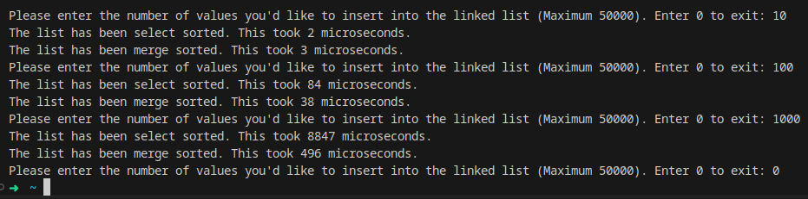

(Optional) GitHub URL

